**Exercise 2: Verifying Interactions Scenario**

**Code:**

**ExternalApi.java:**

package com.example.MockitoDemo;

public interface ExternalApi {

String getData();

}

**VerifyInteractionTest.java:**

package com.example.MockitoDemo;

import static org.mockito.Mockito.*;

import org.junit.jupiter.api.Test;

public class VerifyInteractionTest {

*@Test*

public void testVerifyInteraction() {

ExternalApi mockApi = *mock*(ExternalApi.class);

MyService service = new MyService(mockApi);

service.fetchData();

*verify*(mockApi).getData();

}

}

**Screenshot:** 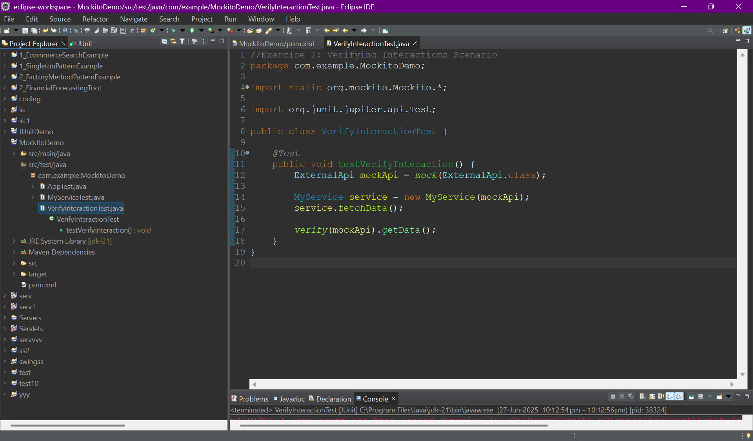

**Output:**

